AgiBot X2 Ultra Documentation Report
Comtrade System Integration – AI/Robotics Team

Contents
Introduction: 3
Components: 3
Head: 3
Torso: 3
Arms: 3
Legs: 3
Software/Jetson: 4
AimDK_X2: 4
AimRT: 5
Jetson Orin NX: 5
Sources: 6

Introduction:
The AgiBot X2 Ultra is a flexible, humanoid robot. It features an NVIDIA Jetson NX 16 GB version. It has 30 total degrees of freedom; 1 degree in the head (x-axis), 7 degrees in the arms, 6 degrees in the legs, as well as 3 degrees in the waist (yaw, pitch, roll). It is 1.31 meters tall and weighs about 39kg. Its operating temperature is between -10°C and 40°C. It has an emergency stop feature using a remote-controlled button that connects to it (tested).
It uses Ubuntu 22.04 with Jetpack 6 for edge AI applications. As a middleware, it utilizes AimRT, which is a software created by AgiBot to act as a publisher-subscriber model for the robot and its limbs, motors, cameras, etc. ROS2 is available and compatible with AimRT. The Jetson is the location of the secondary development for the robot and any additional functionality to be added onto it. It is capable of communicating via Bluetooth, 4G and 5G WiFi.

Components:

Head:
The AgiBot head features a microphone array for multi-directional sound input, as well as 3 RGB cameras on its forehead area (1 interactive RGB, 1 dual RGB camera).
Additionally, it has 1 RGB-D (depth) camera facing at a downward angle from its chin area. It also has a screen which can be used to feature messages and expressions, along with dual stereo speakers (one right, one left side), for output of sound. For safety, it features a back RGB camera, as well as a tactile sensor for touch feedback. It can rotate its head around the x axis (around the neck area).

Torso:
The torso features the battery of the robot, as well as a full-range 3D LIDAR sensor. It also has a protective shell that is easy to remove for repair purposes. The waist features 3 degrees of freedom, that being rotation, pitch, and roll.

Arms:
The arms have arms with 7 degrees of freedom each, allowing for dynamic movement of the robot. Similarly to the torso, it features the easy to remove soft protective shell.

Legs:
The legs have 6 degrees of freedom each, and feature a hollow shaft joint, which has a peak torque of 120Nm. Also has protective removable soft protective shell.

Software/Jetson:

AimDK_X2:

To obtain the SDK and URDF file for development, the documentation instructs to contact after-sales support for the information and data needed.
AimDK X2 contains the different functions for the Robot to use, allowing the developer to create their own functions without needing to write systems level code for the motor controls. The robot also supports both programs such as C++/C and Python, allowing for both low level systems programming, as well as higher level, and ML inference code to be performed on the machine.

The packages are structured by module layers:

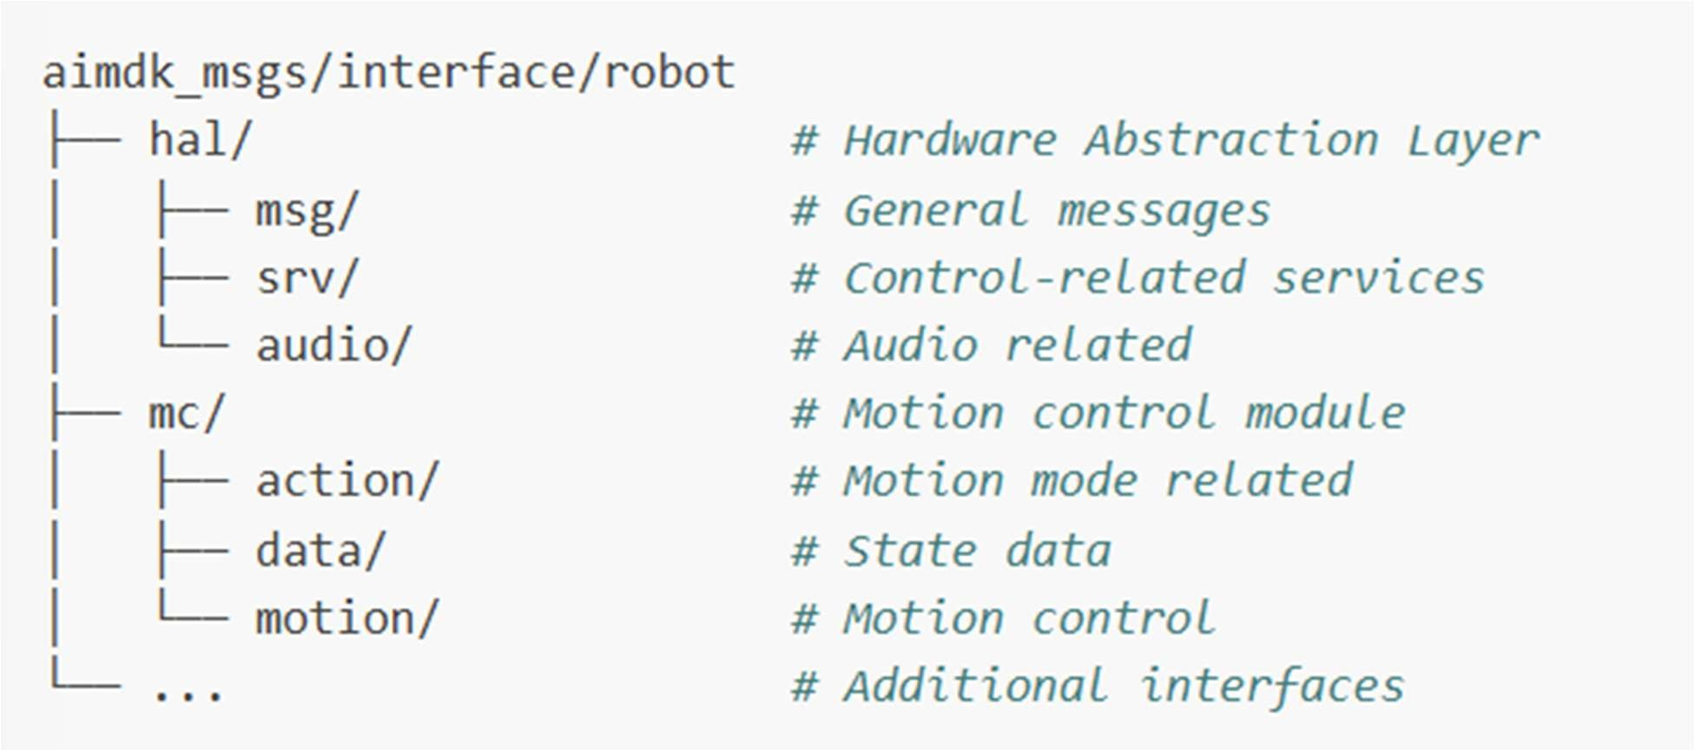
Figure 1: Example of file structure in the package

There are 3 main modules:
- Control module → Provides low-level robot control interfaces including motion control, joint control, and end-effector control.
- Perception module →Provides multimodal perception capabilities including vision and SLAM (according to website, not yet implemented; planned)
- Interaction Module → Provides human-robot interaction interfaces supporting speech, expressions, etc.
These three modules provide the developer with functions to allow for a use of the the robot to an easier degree.
As for the Control Module, there should be no SDK applications deployed on the Motion Control PC (PC1), otherwise, the system may start competing for resources, thus making real-time motion tasks have interference. Otherwise, the control module allows for the developer to control joints, locomotion, arm movements, etc. of the robot. The documentation does recommend making sure the robot is always in a safe state before switching motion modes to make sure the transition happens correctly.

The Interaction module handles interaction between humans and robot, allowing for voice interaction, control of expressions, video, audio and image playback, as well as haptic feedback. It uses standard ROS2 message formats. Most service interfaces use the
/aimdk_5mFmsgs/srv/ and /face_ui_proxy/ prefixes. For message types, they are defined in the aimdk_msgs package.

AimRT:
AimRT is the communication backbone of the robot. It is developed to be a low resource cost, high performance middleware that allows for low latency data architecture across its multi-processor environment.
Similarly to ROS2, it acts a sa bridge between the application layer (AimDK_X2) and the low level motion controls. When a developer triggers a high-level task via Python using the SDK, AimRT serializes that command, routes it across the local network with low-latency, and ensures the low-level motors execute the trajectory safely and synchronously.

Jetson Orin NX:
The NVIDIA Jetson on this robot is an Orin NX, with 16GB of RAM
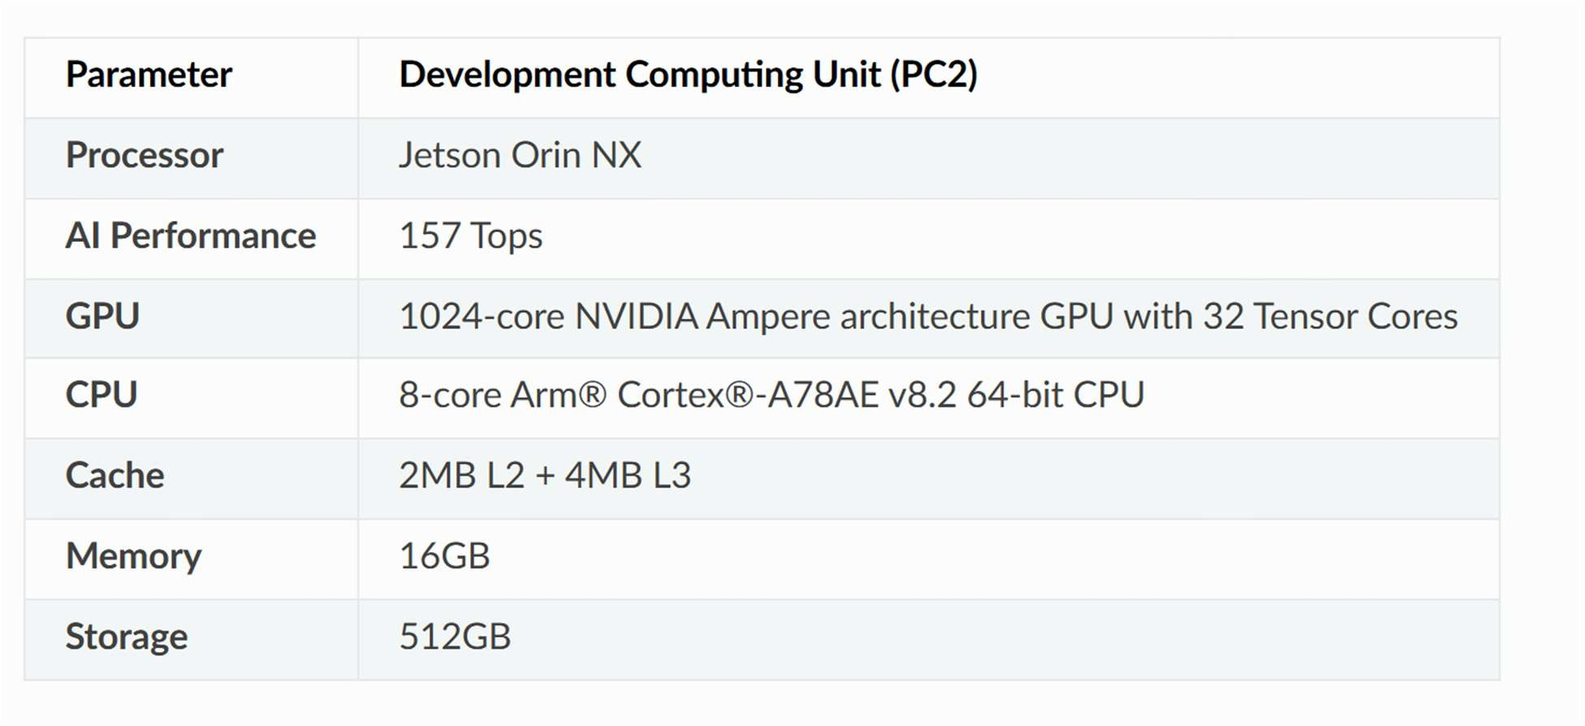
Figure 2: Jetson Orin NX data (From Documentation)

This is where the different functions, software, and AI will run on the robot.

Sources:

Jetson_Orin_NX_Documentation AimDK_X2_Documentation

